Chapter 8, Solution 27.

s² + 4s + 8 = 0 leads to s = 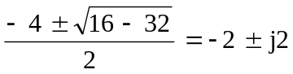

v(t) = V_{s} + (A₁cos2t + A₂sin2t)e^{-2t}

8V_{s} = 24 means that V_{s} = 3

v(0) = 0 = 3 + A₁ leads to A₁ = -3

dv/dt = -2(A₁cos2t + A₂sin2t)e^{-2t} + (-2A₁sin2t + 2A₂cos2t)e^{-2t}

0 = dv(0)/dt = -2A₁ +2A₂ or A₂ = A₁ = -3

v(t) = [3 – 3(cos(2t) + sin(2t))e^{–2t}] volts.

